Procedure to develop JSP pages based java web application with out Eclipse

======================================================

* The content of web root folder like(JSP App1 or JSPApp2 folders) is called public area.
* WEB-INF and its sub folders content of any web applications deployment directly structure is called private area of the web application.

**Example:1** The JSP comp/file is placed in public area.

Step1) create Deployment Directory structure.

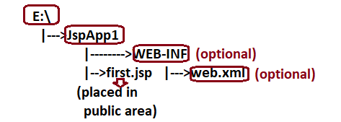

Step2) Develop “first.jsp”.

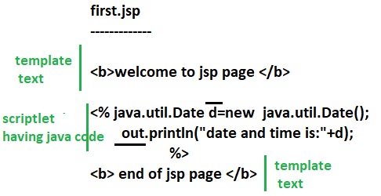

Note1: JSP page/file will not be compiled from cmd prompt. So there is no need of adding any jar file in class path for jsp page/comp/file.

Step3) Deploy the web application in tomcat web server.

Copy the web application directory structure to <Tomcat_home>\webapps

Step4) Start the Tomcat Server.



Step5) Test the web application.



The modifications done in jsp page will be reflected to output directly with out doing any recompilations and reloading because for every modification done to jsp page internally a new jsp equalent servlet comp will be generated and compiled.

**Example:2** The JSP comp/file is placed in private area.

Step1) Create a Deployment directory structure.

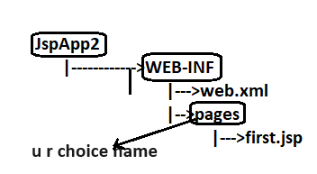

Step2) Develop the First.jsp

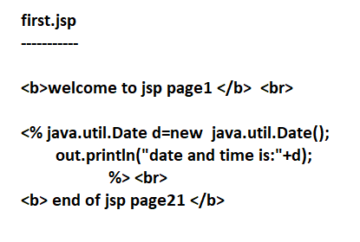

Step3) Create a web.xml file. Write a logic in that.

The jsp file is placed in private area of the web application then jsp configuration in web.xml file is mandatory.

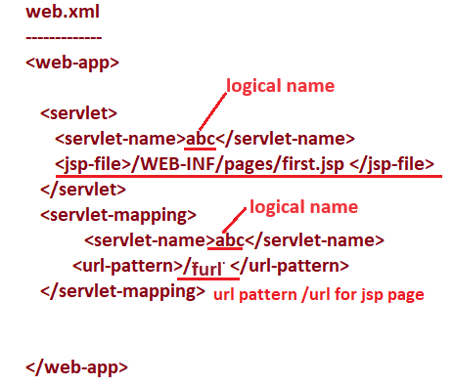

Step4) Deploy the web application in tomcat web server.

Copy the web application directory structure to <Tomcat_home>\webapps

Step5) Start the Tomcat Server.



Step6) Test the web application.



Note:- we can not configure jsp page with annotations … because jsp page programming is tag based programming and we can not apply annotations on the top of it. So jsp page configuration is possible only through web.xml file.